Select the Scan tab on the Demo tool GUI to actively scan for nearby Access Points. The user can choose between the following scan types:

1. Standard Wi-Fi Scan
2. Low Power Wi-Fi Smart Scan

Default values of parameters for Standard Wi-Fi and Low-Power Wi-Fi scan are shown in Table 1. Depending on the user’s choice of the scanning scheme, respective default values will be set to corresponding parameters.

|  |  |  |  |
| --- | --- | --- | --- |
| **Default Value** | | | |
| **Parameters** | **Standard Wi-Fi scan** | **Low-Power Wi-Fi Scan** | **Remark** |
| **No_of_Probes** | 2 | 1 | Configurable |
| **Ide_Slots** | 3 | 3 | Configurable |
| **Select the Required Probe Rate** | 11b_1Mbps | 11b_6Mbps | Configurable |
| **NAP Enable** | No | Yes | Hard coded |

Table 1: Default values for Standard Wi-Fi and Low-Power Wi-Fi Scan

## Case 1: Standard Wi-Fi Scan

1. In this mode of scan, Talaria TWO will dwell 40ms on each channel.
2. Hence, to scan all 2Ghz channels, it will take ~520ms in clean environment.
3. In a crowded environment, it will take additional time to complete full scan based on the channel condition.

Console output for Standard Scan Scheme:

|  |
| --- |
| UART:SNWWWWWAEBuild $Id: git-ba65998b7 $  mpd.proto=scan wifi.scan_num_probes=2 wifi.scan_idleslots=3 wifi.scan_min_listen_time=8 wifi.scan_max_listen_time=40 wifi.scan_wait_time=0 wifi.nap_scan=0 mpd.scan.dt_iterations=10 wifi.probe_rate=0x00 wifi.scan_channel_mask=0x7ff mpd.regdomain=FCC mpd.suspend=1  $App:git-73e7f910  SDK Ver: FREERTOS_SDK_1.0  T2 Multipurpose Demp App Version 0.12  Suspend Enabled.  Regdomain=FCC  addr e0:69:3a:00:13:90  Applying reg domain: 1-11@20  MPD scan mode.  Channels to be scanned=1,2,3,4,5,6,7,8,9,10,11  Enabling suspend.  period=10  Round:1 Found 9 nets:  00:5f:67:cd:c5:a6 on channel 11 @ -60 'InnoPhase' 'WPA2-PSK'  b0:a7:b9:73:8e:51 on channel 4 @ -73 'Lakshmi pg 2nd floor 2g' 'WPA2-PSK'  ba:6b:ad:62:6d:8b on channel 11 @ -79 'DESKTOP-9B1DNVC 1786' 'WPA2-PSK'  e4:a7:c5:d4:ea:86 on channel 6 @ -82 'Airtel-E5573-EA86' 'WPA2-PSK'  d8:47:32:2e:e1:e0 on channel 11 @ -83 'GPMH' 'WPA2-PSK'  3c:1e:04:2d:c1:01 on channel 11 @ -85 'Lakshmi pg 1st floor' 'WPA-PSK/WPA2-PSK Mixed Mode'  34:e8:94:be:16:9b on channel 1 @ -88 'InfecteD v2.4' 'WPA2-PSK'  dc:71:37:56:91:b0 on channel 8 @ -90 'Hathway_Raghuram' 'WPA-PSK/WPA2-PSK Mixed Mode'  50:2b:73:98:0f:51 on channel 9 @ -92 'SharmaShesCheatingonYou' 'WPA-PSK/WPA2-PSK Mixed Mode'  -------------------------  Round:2 Found 7 nets:  00:5f:67:cd:c5:a6 on channel 11 @ -52 'InnoPhase' 'WPA2-PSK'  34:0a:33:70:f3:a2 on channel 1 @ -78 'Siddusm' 'WPA2-PSK'  90:8d:78:fa:54:60 on channel 10 @ -79 'LAKSHMI PG 4TH FLOOR' 'WPA2-PSK'  e4:a7:c5:d4:ea:86 on channel 6 @ -82 'Airtel-E5573-EA86' 'WPA2-PSK'  70:4f:57:77:7e:d4 on channel 2 @ -84 'Rahul' 'WPA2-PSK'  dc:71:37:56:91:b0 on channel 8 @ -84 'Hathway_Raghuram' 'WPA-PSK/WPA2-PSK Mixed Mode'  aa:74:84:e0:c9:a0 on channel 4 @ -94 'SUMAIYA' 'WPA-PSK/WPA2-PSK Mixed Mode'  -------------------------  Round:3 Found 2 nets:  00:5f:67:cd:c5:a6 on channel 11 @ -60 'InnoPhase' 'WPA2-PSK'  e4:a7:c5:d4:ea:86 on channel 6 @ -79 'Airtel-E5573-EA86' 'WPA2-PSK'  -------------------------  Round:4 Found 3 nets:  34:0a:33:70:f3:a2 on channel 1 @ -80 'Siddusm' 'WPA2-PSK'  e4:a7:c5:d4:ea:86 on channel 6 @ -80 'Airtel-E5573-EA86' 'WPA2-PSK'  34:e8:94:be:16:9b on channel 1 @ -90 'InfecteD v2.4' 'WPA2-PSK' |

**Expected Result**: Depending on the scan specifications, available networks are identified and displayed.

**Otii log**: Shows an average current consumption of 43.7mA for 99.950ms scan duration, here the FCC regulatory domain is enabled.

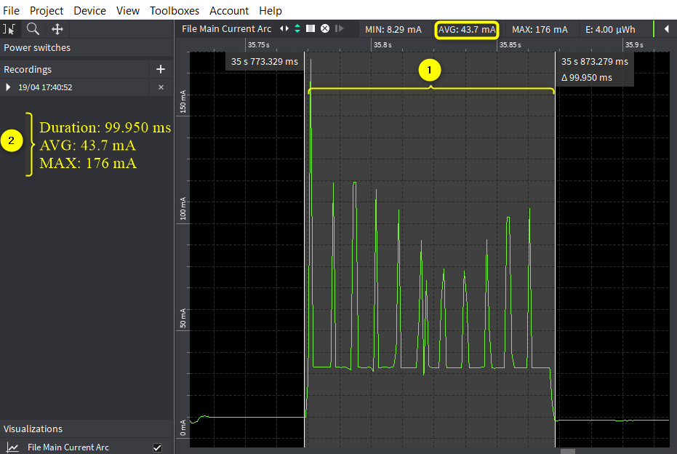

Figure 1: Case 1 - Standard scan - Otti log

## Case 2: Low Power Wi-Fi Smart Scan

Overall current consumption can be reduced by one of the following methods:

1. Dynamic dwelling
   1. Based on the channel condition, Talaria TWO can stay minimum channel time or maximum channel time.
   2. Normally, minimum channel time is configured to 8ms, and maximum channel time is configured to 24ms.
   3. While scanning, Talaria TWO will decide after every minimum channel time, whether to stay on channel or move to next channel.
   4. Staying in the channel is based on channel condition. Talaria TWO will identify this by number of idle slots at the end of minimum channel time.
2. Napping
   1. After probe, if Talaria TWO receives packet other than the Probe response and Beacon, Talaria TWO will take a NAP based on the duration of packet received.

Console output for Low Power scan scheme:

|  |
| --- |
| UART:SNWWWWWAEBuild $Id: git-ba65998b7 $  mpd.proto=lpscan wifi.scan_num_probes=1 wifi.scan_idleslots=3 wifi.scan_min_listen_time=8 wifi.scan_max_listen_time=24 wifi.nap_scan=1 mpd.lpscan.ap_logging=1 mpd.lpscan.dt_iterations=10 mpd.lpscan.rate=0x100 wifi.scan_channel_mask=0x7ff mpd.regdomain=FCC mpd.suspend=1  $App:git-73e7f910  SDK Ver: FREERTOS_SDK_1.0  T2 Multipurpose Demp App Version 0.12  Suspend Enabled.  Multicast reception Disabled.  Regdomain=FCC  addr e0:69:3a:00:13:90  Applying reg domain: 1-11@20  MPD lpscan mode.  Enabling suspend.  [1.718,157] Round:1 Found 3 nets:  -------------------------  [1.718,817] 00:5f:67:cd:c5:a6 on channel 11 @ -45 'InnoPhase' 'WPA2-PSK'  [1.718,929] b0:a7:b9:73:8e:51 on channel 4 @ -70 'Lakshmi pg 2nd floor 2g' 'WPA2-PSK'  [1.719,042] 34:0a:33:70:f3:a2 on channel 1 @ -77 'Siddusm' 'WPA2-PSK'  [11.698,197] Round:2 Found 3 nets:  -------------------------  [11.698,286] ba:6b:ad:62:6d:8b on channel 11 @ -67 'DESKTOP-9B1DNVC 1786' 'WPA2-PSK'  [11.698,401] b0:a7:b9:73:8e:51 on channel 4 @ -71 'Lakshmi pg 2nd floor 2g' 'WPA2-PSK'  [11.698,517] d8:47:32:2e:e1:e0 on channel 11 @ -79 'GPMH' 'WPA2-PSK'  [21.693,819] Round:3 Found 2 nets:  -------------------------  [21.693,903] 34:0a:33:70:f3:a2 on channel 1 @ -78 'Siddusm' 'WPA2-PSK'  [21.694,019] 30:b6:2d:94:37:a0 on channel 1 @ -86 'JioPrivateNet' 'WPA2/WPA3-Enterprise'  [31.684,572] Round:4 Found 2 nets:  -------------------------  [31.684,656] 00:5f:67:cd:c5:a6 on channel 11 @ -47 'InnoPhase' 'WPA2-PSK'  [31.684,769] f8:c4:f3:18:2e:08 on channel 2 @ -91 'Shiva_Airtel' 'WPA2-PSK'  [41.702,628] Round:5 Found 3 nets:  -------------------------  [41.702,713] 00:5f:67:cd:c5:a6 on channel 11 @ -57 'InnoPhase' 'WPA2-PSK'  [41.702,828] ba:6b:ad:62:6d:8b on channel 11 @ -66 'DESKTOP-9B1DNVC 1786' 'WPA2-PSK'  [41.702,943] 70:4f:57:77:7e:d4 on channel 2 @ -85 'Rahul' 'WPA2-PSK' |

**Otii log**: Shows an average current consumption of 32.8mA for 96.032ms scan duration for low power Wi-Fi smart scan, here FCC regulatory domain is enabled.

**Note**: The capture is taken in a clean environment.

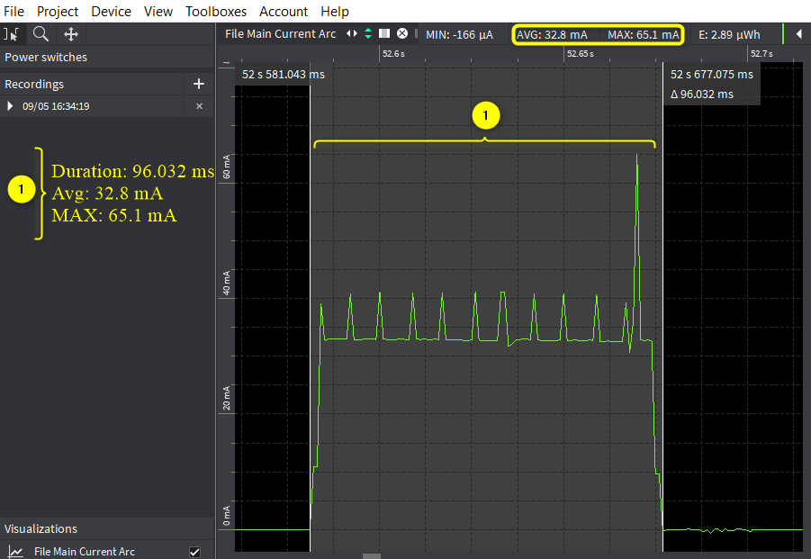

Figure 2: Low power Wi-Fi smart scan - Otti log

**Note:** Following are some of the use cases that can be configured manually by the user on the MPD GUI scan tab, which is applicable for both Standard and Low Power Smart scan:

1. The Scan tab allows the user to actively scan for nearby Access Points by default parameters.
2. Regulatory Domain: Depending on the user’s geographical location, any one of the listed Regulatory Domains can be selected.
3. Channel_list: Set the Wi-Fi channels to be used.

For example: Set 1-11,13 to use channels 1 to 11 and 13, depending on the selected Regulatory Domain.

1. Prob_rate: The rate as defined by rate_t is used to transmit the probe request. If this field is set to 0xffff, no probes will be sent and the scan will only be passive.
2. Setting the SSID.

SSID (Service Set Identifier) is the name of the user’s wireless network, also known as Network ID. If the SSID of the network is provided and the BSSID field is kept empty, it scans for the network as per the provided SSID and gives the following details:

* 1. BSSID
  2. Channel
  3. RSSI Range
  4. Mode

1. Setting the BSSID.

BSSID recognizes the AP or router as it has a unique address which creates the wireless network. To set the BSSID of a network, enter the BSSID in the provided field and click on Start.